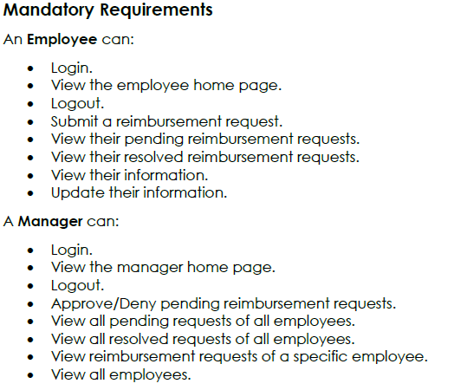

2 tables

Java & DB

User will contain:

* Id (int on DB and java, will be the primary key)
* Full name (varchar on DB, String in java)
* Username (varchar on DB, String in java)
* Password (varchar on DB, String in java)
* Role (varchar on DB, String in java)

DB

Reimbursement:

* Id (will be the primary key, that references the id of the user it originates from)
* Date (date…?)
* Ref (varchar2)
* Due (float)
* Total (float)
* Status (closed, pending)

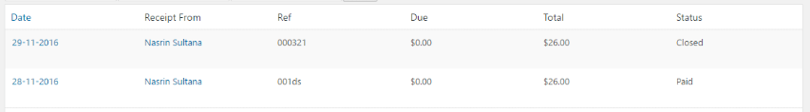

Will use the DAO for creating a user

For displaying reimbursements:

* Use FETCH or AJAX to get reimbursement objects on front end
* Use JS to manipulate DOM + produce dynamic response

Don’t want to just use:

* Resp.getWriter.write{

An entire table in html here};

7/4/19:

Making a page for employees and a page for managers within the web-inf

Changed the doPost method in the loginServlet from the example Adam gave us, to simply call the method from project 0, to validate the user information. If that method returns null, then send them to an invalid entry page

7/4

FINISHED Login for Manager & User

**FINISHED** backend in java/SQL:

* Employee login
* View a single employee’s pending/resolved reimbursement requests
* View a single employee’s information
* Update current employee information
* Manager login
* Approve/deny pending reimbursement requests
* View all pending/resolved requests of all employees
* View all employees (not sure if this means just their names or not…)

**FINISHED** Website part:

* Employee login
* Logout
* View a single employee’s information
* View a single employee’s pending reimbursement requests
* View a single employee’s ‘approved’ or ‘denied’ reimbursement requests
* Manager login
* Logout
* View all pending/completed requests of all employees
* View reimbursement requests of a specific employee
* View all employees
* Approve/deny pending requests

Adding fetch is the main difficulty. Everything works… but I can’t really figure out how to parse it into html out of JSON